**PROJECT PLAN**

**on**

**“APP REVIEWER”**

**By**

**Vinil Kumar Kamigari**

**Sumanth Koushik Kalli**

**Alekhya Boyapati**

**APP REVIEWER**

**______________________________________________________________________________**

**Introduction:**

In the recent years, there is a significant increase in the number of mobile web applications being developed every day. According to a recent survey there are around 9 billion mobile users in the world today and this number is expected to increase to 24 billion by 2020. As the number of smart phone users increased, they got accustomed to web applications which are making their lives lot simpler and easier. The craze among people for web applications pushed them towards learning application development and tools such as Microsoft Visual studio expedited the process of developing applications for mobiles easily in very short period. Thus, the number of applications is increasing exponentially irrespective of the platform such as Windows, Android and iOS. With huge number of applications in their app store users are confused on choosing applications according to their requirement, to solve this problem we would like to implement “Application Reviewer”.

“Application Reviewer” helps the user in selecting the appropriate app according to their requirements, provides honest, genuine reviews for that app from its previous users and also recommends related apps to the user. This application helps the users in choosing the correct application for their required functionality.

**Project Goals and Objectives**

______________________________________________________________________________

* **Overall Goal:**

Our goal is to provide sophisticated, bug-free apps to the user from the category he/she requests with the user’s own prior reviews from other users.

* **Problem statement:**

In the present Mobile web application industry, selecting a required application for our mobile phone is becoming more hectic for user as numbers of applications for each purpose is increasing exponentially every day and time has arrived where in another Mobile Web application needs to be developed to give the user with an intelligent, more efficient application according to his/ her needs. In order, to solve this problem we came up with the present “App Reviewer” to assist the user.

* **Significance:**

The Significant features of the proposed project are when a user requests information in certain category, then the application will pop up with Description of the application, Version history, Developer information, Size and number of users presently using it along with honest reviews from other users and allows the user to take a wise decision on selecting the appropriate app.

**Project Background and Related work**

_____________________________________________________________________________________

1. There have been many applications and websites which are developed to give reviews about apartments, food, restaurants etc. such as yelp.com, rent.com etc.
2. Recently, software is also developed to give reviews and ratings. This software can be downloaded from reziew.com

### **Proposed System**

_____________________________________________________________________________________

* Functional requirements:

1. The app will produce the details of particular application either by user’s interest or based on the application category.

2. It will produce the details of particular application such as its description of application, number of users currently using, reviews and also developer information.

* Non-functional requirements:

1. Basically this app requires a mobile with internet connection for searching an application.
2. We need a user for searching that application based on his/her interest or based on the category.

### Technological and Architectural Requirements:

#### **Server Operating System:**

#### The server will run Red Hat Enterprise Linux v6. IP address for this server will be 170.224.168.159.

Server configuration: Copper - 32 bit (vCPU: 1, RAM: 2 GiB, Disk: 60 GiB) root-only

Disk size: 60 GiB

Hostname: vhost2199.site1.compute.ihost.com

#### **JavaScript / Presentation Framework:**

We will use JQuery Mobile to render the client side user interface. Web pages themselves will be rendered by the server and inserted into the DOM by JQuery Mobile.

#### **Mobile Phone Requirements**

Any mobile browser that supports JQuery Mobile and HTML5 will be supported. This includes virtually all modern iOS or Android devices. No application will be developed for native phones.

#### **Web Framework**

We have tentatively selected the Play framework as a web application framework that generates JQuery Mobile pages themselves.

#### **Data Set**

The data set that is used in the project is Hadoop. Here we use Hadoop for both storing of data and analyzing the data that is being stored.

Framework specification: Build an overall system model

________________________________________________

* Assumptions and Principles:

Our Application assumes the user to have primary knowledge about the app he/she is searching for and he/she has a mobile phone connected to the internet.

* Methodologies and Algorithms:

We follow Agile development model to develop this application and use HTML5, CSS3 and JavaScript in the front end and also use jQuery Mobile. We also make use of REST to provide web services. The web services are used to integrate this application with Hadoop. We make of MapReduce algorithm which contains Map() to perform filtering and sorting and Reduce() to perform summary operation.

* System Architecture Diagram:

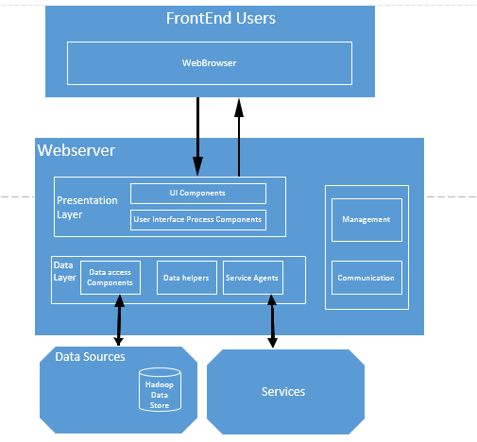

System specification: Identify Primary services

___________________________________________

**Existing Services:**

1. **HADOOP:**

Hadoop is an open-source software framework that supports data-intensive distributed applications. It helps in executing applications on large clusters of hardware. It is developed by Apache Software Foundation.

1. **jQUERY Mobile:**

jQuery Mobile is a touch-optimized web framework currently being developed by jQuery project team. They focus on creating a framework which is compatible with many smart phones and tablet computers, which are necessary in the growing market. The jQuery Mobile framework is compatible with other mobile app frameworks and platforms such as PhoneGap and Worklight.

1. **RESTFULL Services:**

Representational State Transfer (REST) is an architectural style that shows the architectural elements within a distributed hypermedia system. REST ignores the details of component implementation and protocol syntax in order to focus on the roles of components, the constraints upon their interaction with other components, and their interpretation of significant data elements. REST has emerged as a predominant web API design model.

**New Services to be built:**

#### User searches for best matching app based on User’s Interest.

The user searches for those apps that are best matched to his/her interest.

1. User selects our app on his/her mobile phone.
2. User clicks on “Search according to Interest”.
3. User is presented with a list of apps that match his/her interest based on the number of users presently using it.
4. User selects an app from the plethora of apps available.
5. User is presented with reviews of the selected app.

* User searches for app based on category

The user searches for apps within a list of categories mentioned in our app.

1. User selects our app on his/her mobile phone.
2. User clicks on “Search according to Category”.
3. User is presented with a list of apps that are in the specified category based on the number of users presently using it.
4. User selects an app from the plethora of apps available.
5. User is presented with reviews of the selected app.

User Cases:

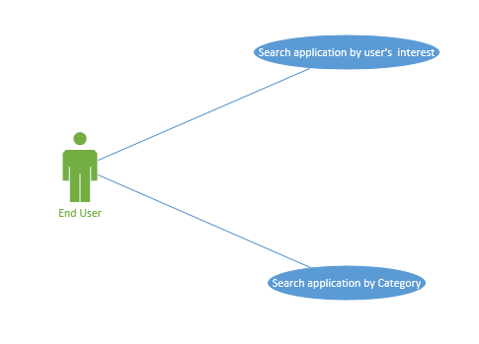

Sequence Diagram:

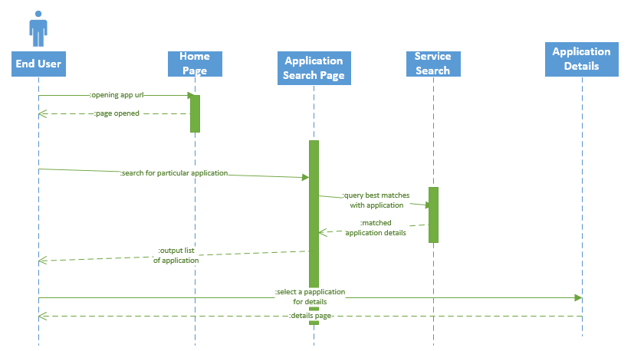

**BIBLIOGRAPHY**

**______________________________________________**

1. Hadoop

<http://en.wikipedia.org/wiki/Apache_Hadoop>

<http://hadoop.apache.org/>

1. JQuery Mobile

<http://en.wikipedia.org/wiki/JQuery_Mobile>

<http://jquerymobile.com/>

1. RESTFUL Services

<http://en.wikipedia.org/wiki/Representational_state_transfer>

1. Customer Reviews and Ratings.

<http://www.reziew.com/>

1. Review Websites

<http://www.yelp.com/kansas-city-ks-us>,

<http://www.rent.com/>